Energy Efficient Architecture for Graph Analytics Accelerators

Corresponding author

Muhammet Mustafa Ozdal†, Serif Yesil†, Taemin Kim*, Andrey Ayupov*, John Greth*, Steven Burns*, and Ozcan Ozturk†

†Bilkent Univ. Ankara, Turkey

*Intel Corp. Hillsboro, OR 97124

Keywords

Graph-Parallel; Graph Analytics Applications

Summary

*Challenge*

Many existing works focus on accelerating compute-intensive tasks using programmable hardware (e.g. GPUs, CPU vector extensions such as SSE and AVX) or custom hardware. A common characteristic of these applications is the regularity and the abundance of data and thread level parallelism. However a certain class of **graph analytics applications** with **irregular execution patterns** make them hard to accelerate using existing platforms.

To be detailed, common characteristics of iterative graph-parallel applications have been studied recently, and the desired architectural features have been identified as follows:

1. **Asymmetric Convergence**: The number of iterations each vertex needs to be processed before convergence may vary significantly for graph analytics applications.
2. **Asynchronous Execution**: In contrast to bulk-synchronous iterative algorithms, there are **no well defined iterations in an asynchronous algorithm**, and the vertices can access the latest data computed by their neighbors. Although more work efficient, an asynchronous implementation may run slower because of potential synchronization overheads. Race conditions are possible.
3. **Memory Access Bottlenecks**: It is known that memory access can be the main bottleneck for graph analytics workloads. The main reason is that a **small amount of computation** is typically performed **per vertex and edge**, but a **large number of vertices and edges** need to be processed for large graphs.
4. Load Imbalance: Vertex degrees of real graphs (e.g. social networks) follow the Power law distribution, where a small percent of vertices cover most of the edges. **Assigning vertices to threads statically can lead to severe load imbalances**.

General Purpose CPUs meet surprisingly low IPCs (most below 1.0), and GPUs can’t handle the graph analysis problem well because of the SIMD nature of GPU leading to both control

and memory divergence due to irregularity of graph applications.

*Contribution*

Focus on such a large class of graph applications, the authors

1. Propose an architecture specifically optimized for vertex-centric, iterative, graph-parallel applications with irregular access patterns and asymmetric convergence. The proposed architecture supports the more work-efficient asynchronous execution
2. Provide cycle-accurate and synthesizable SystemC models that implement the proposed architecture template
3. Provide an experimental study that compares the area, power, and performance of the generated hardware accelerators with CPU implementations

The proposed architecture include specialized processing unit and memory hierarchy for graph analysis algorithms. Tens of vertices and hundreds of edges are processed simultaneously to achieve high levels of memory-level parallelism, scale-free graphs are handled through dynamic load balancing, while Synchronization between concurrently processed vertices and edges is done in the Sync Unit (SYU) module specifically designed for graph processing. The accelerator are tested for different graph applications including PageRank (PR), Loopy Belief Propagation (LBP), Stochastic Gradient Descent (SGD), and Single Source Shortest Path (SSSP).

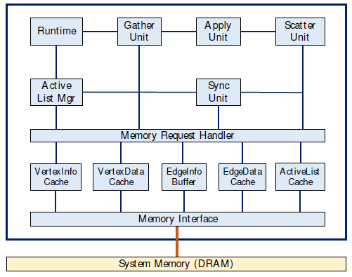

*Result*

Compared to a 24 core high end IvyBridge server system, the hardware accelerators generatedby the proposed template outperformed by up to 3x in terms of performance, and the physical-aware logic synthesis showsup to 65x better power consumption with significantly smallerarea. GPU system is not compared due to the work-efficiency advantages of asynchronous execution and asymmetric convergence.

*Possible Improvements*

The paper proposed a hardware accelerator specific for graph analysis problem, which is not significantly related to neural networks. The computation patterns of graph algorithms differ from those of NN algorithms. The paper is structural completed, using template that receive application-level data structures and operations to generate hardware accelerators for each application.